Shape Your Dreams, Build Your Future!

AZURE
PLACEMENT
ORIENTED!

Online Live Digital Board 1:1 Mentorship
200+ coding Exercises Placement Assistance Program Interview Preparation
program

Data is New Oil
We just dont teach we believe in Teaching with Results

For more info:
















+91-9989454737 https://learn.seekhobigdata.com/ Hyderabad,Telangana



Learning Phase

Phase
Placement

Interview Phase

Three Different Phases will help you to upskill Yourself With in 2-2.5 month and grab
100-500% Hike
www.seekhobigdata.com







T A B L E O F C O N T E N T S

01.
02.
03.

INTRODUCTION

Azure Setup
Azure DataBricks
PROCESSING
ADF
INGESTION TOOL
Environment

04.
05.
06.
DATAWAREHOUSE
FABRIC
PLACEMENT

Azure Synapse
Azure Fabric
Placement Assistance



T A B L E O F C O N T E N T S

07
08
PROJECTS
INTERVIEW

PROJECTS
Interview Preparation Program

Feedbacks From Our Students

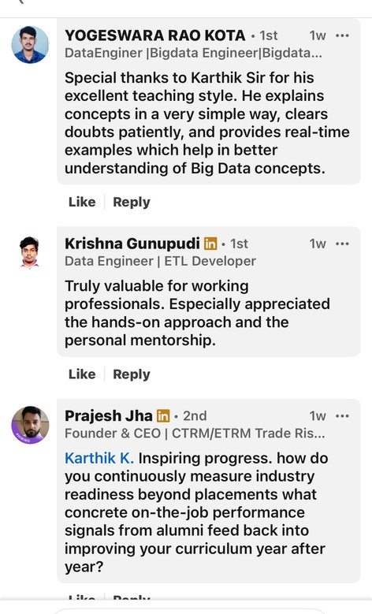
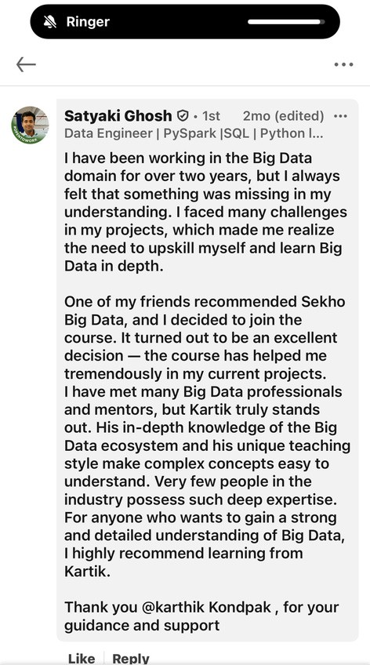
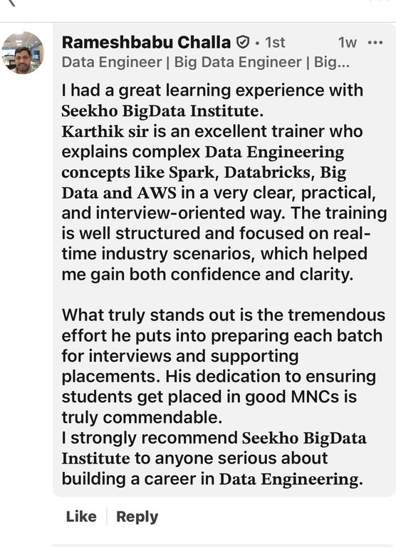

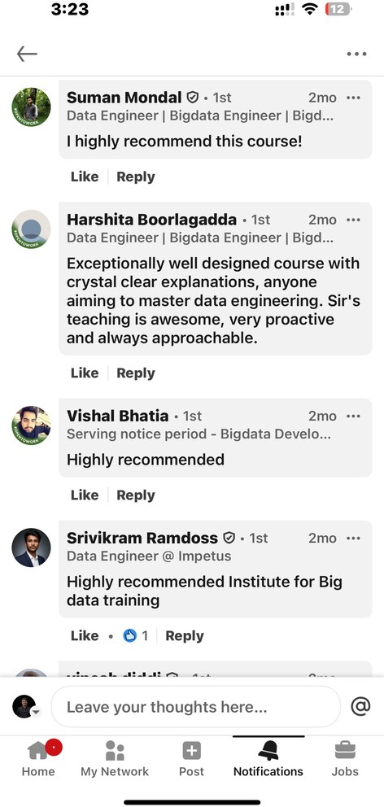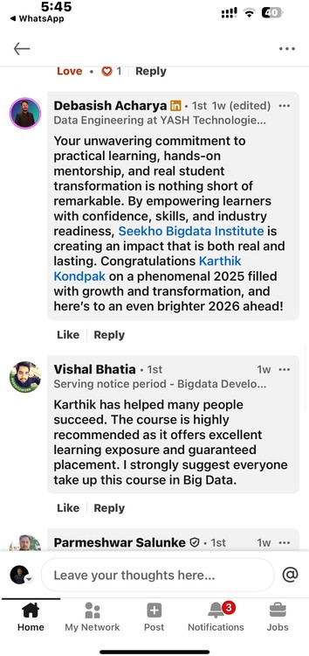

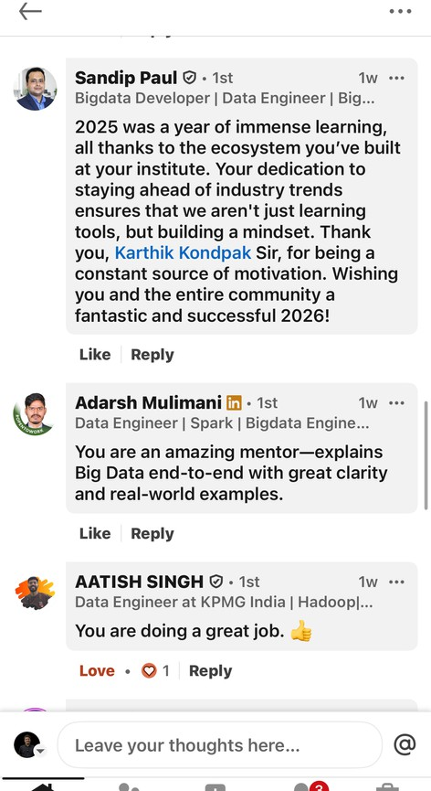
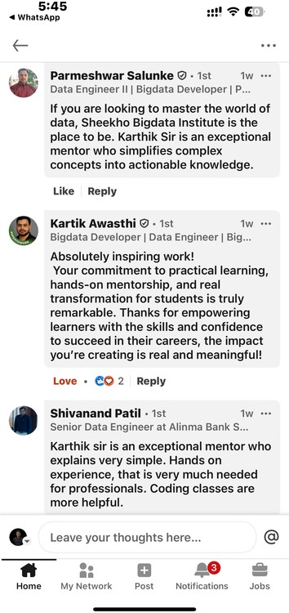

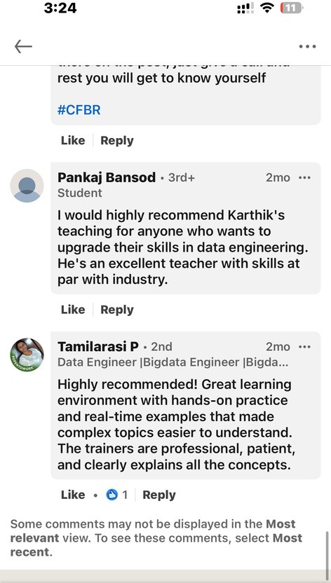
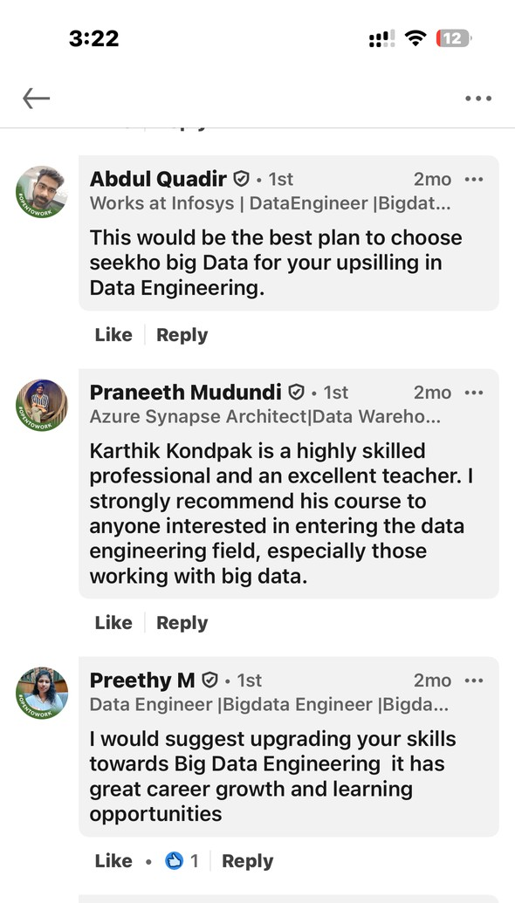
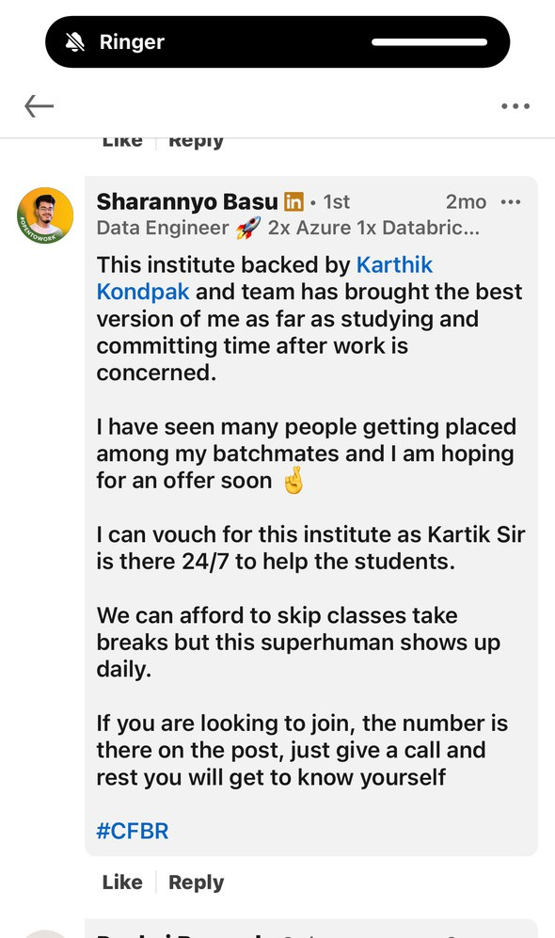
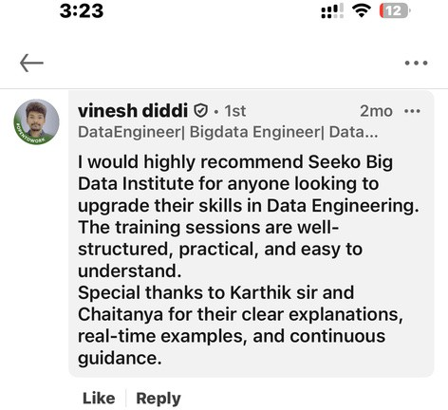



Overview
Goal: Overview of Cloud PlatForms

Cloud Computing Platforms / Vendors
OVERVIEW OF MAJOR CLOUD PLATFORMS MICROSOFT AZURE – OVERVIEW AND POSITIONING AWS (AMAZON WEB SERVICES) – OVERVIEW GOOGLE CLOUD PLATFORM (GCP) – OVERVIEW MARKET COMPARISON OF AZURE VS AWS VS GCP COMMON INDUSTRY USE CASES
WHY AZURE IS PREFERRED FOR DATA ENGINEERING WORKLOADS

Introduction to Microsoft Azure
WHAT IS MICROSOFT AZURE
AZURE CLOUD SERVICE MODEL
AZURE GLOBAL INFRASTRUCTURE OVERVIEW AZURE REGIONS AND AVAILABILITY ZONES
AZURE ACCOUNT AND SUBSCRIPTION SETUP OVERVIEW

Azure Portal Walkthrough


AZURE PORTAL OVERVIEW
NAVIGATING AND USING THE AZURE PORTAL CORE AZURE CONCEPTS

WHAT IS A SUBSCRIPTION WHAT IS A RESOURCE GROUP WHAT IS A RESOURCE
UNDERSTANDING AZURE RESOURCE HIERARCHY
MANAGING RESOURCES THROUGH THE AZURE PORTAL

D.Overview of Azure Storage Accounts
WHAT IS AN AZURE STORAGE ACCOUNT TYPES OF AZURE STORAGE ACCOUNTS AZURE BLOB STORAGE CONCEPTS
ACCESS TIERS HOT
COOL
ARCHIVE
DATA REPLICATION AND REDUNDANCY OPTIONS LRS – LOCALLY REDUNDANT STORAGE
ZRS – ZONE REDUNDANT STORAGE



GRS – GEO- REDUNDANT STORAGE

GZRS – GEO- ZONE REDUNDANT STORAGE
AZURE DATA LAKE STORAGE GEN 2 ARCHITECTURE
BLOB STORAGE VS ADLS GEN 2 – DIFFERENCES AND USE
CASES

F.Azure Key Vault

INTRODUCTION TO AZURE KEY VAULT
IMPORTANCE OF AZURE KEY VAULT IN DATA ENGINEERING KEY VAULT USE CASES
KEY VAULT OBJECTS KEYS
SECRETS
CERTIFICATES
CREATING AND CONFIGURING AZURE KEY VAULT
SECURE ACCESS TO AZURE KEY VAULT FROM AZURE SERVICES




Introduction & Environment Setup

Goal: Understand Data Engineering basics and set up Azure environment

WHAT IS DATA ENGINEERING
AZURE DATA FACTORY – OVERVIEW & ARCHITECTURE CREATING AZURE FREE ACCOUNT
AZURE PORTAL OVERVIEW CREATING AZURE DATA FACTORY
CREATING AZURE DATA LAKE STORAGE GEN2 CREATING AZURE SQL DATABASE


ADF


- Goal: Understand building blocks of ADF

TOP-LEVEL CONCEPTS IN ADF
LINKED SERVICES, DATASETS & PIPELINES
DEMO – CREATING LINKED SERVICES, DATASETS & COPY ACTIVITY

Integration Runtime (Compute Layer)

Goal: Understand how and where pipelines run

INTEGRATION RUNTIME – OVERVIEW TYPES OF INTEGRATION RUNTIME AZURE IR
SELF-HOSTED IR AZURE-SSIS IR
DATA SOURCE LOCATIONS (ON-PREM VS CLOUD) TASK – SELF-HOSTED INTEGRATION RUNTIME DEMO – SELF-HOSTED INTEGRATION RUNTIME SHARING SELF-HOSTED INTEGRATION RUNTIME
DEMO – SHARED SELF-HOSTED INTEGRATION RUNTIME

Control Flow Activities (Pipeline
Orchestration)


Goal: Build dynamic, conditional, and loop-based pipelines
GET METADATA ACTIVITY FOREACH ACTIVITY
IF CONDITION ACTIVITY

DEMO – GET METADATA, FOREACH & IF DELETE ACTIVITY
DEMO – DELETE ACTIVITY LOOKUP ACTIVITY
STORED PROCEDURE ACTIVITY
DEMO – LOOKUP & STORED PROCEDURE SWITCH ACTIVITY
DEMO – SWITCH
DEPENDENCY CONDITIONS (SUCCESS, FAILURE, COMPLETION) FAIL ACTIVITY
DEMO – DEPENDENCY & FAIL WAIT ACTIVITY
DEMO – WAIT
NESTED PIPELINES (EXECUTE PIPELINE) DEMO – NESTED PIPELINES
UNTIL ACTIVITY DEMO – UNTIL

Mapping Data Flows –
Transformations


BASIC TRANSFORMATIONS SELECT
FILTER AGGREGATE
DEMO – SELECT, FILTER & AGGREGATE CONDITIONAL & MULTI-PATH
CONDITIONAL SPLIT
DEMO – CONDITIONAL SPLIT EXISTS

DEMO – EXISTS JOIN & MERGE JOIN
DEMO – JOIN
UNION
DEMO – UNION
LOOKUP & DERIVED LOGIC LOOKUP (DATA FLOW) DEMO – LOOKUP
DERIVED COLUMN
DEMO – DERIVED COLUMN KEYS & DATA QUALITY SURROGATE KEY



DEMO – SURROGATE KEY ASSERT
DEMO – ASSERT ALTER ROW
SEMI-STRUCTURED & COMPLEX DATA PARSE
DEMO – PARSE STRINGIFY
DEMO – STRINGIFY FLATTEN
DEMO – FLATTEN
ADVANCED TRANSFORMATIONS WINDOW
DEMO – WINDOW PIVOT
DEMO – PIVOT UNPIVOT
DEMO – UNPIVOT FLOWLETS
DEMO – FLOWLETS


Parameterization & Reusability


Goal: Build reusable and dynamic pipelines

PIPELINE PARAMETERS DATASET PARAMETERS
LINKED SERVICE PARAMETERS
DEMO – PARAMETERIZING PIPELINES

Triggers & Scheduling

Goal: Automate pipeline execution
TRIGGERS – OVERVIEW SCHEDULE TRIGGER
DEMO – SCHEDULE TRIGGER STORAGE EVENT TRIGGER
DEMO – STORAGE EVENT TRIGGER TUMBLING WINDOW TRIGGER
DEMO – TUMBLING WINDOW TRIGGER




Security & Networking

Goal: Secure pipelines and control network access
AZURE KEY VAULT INTEGRATION DEMO – AZURE KEY VAULT NETWORKING FOR ADF
AZURE-PROVIDED INTEGRATION RUNTIME NETWORKING DEMO – NETWORKING AZURE PROVIDED IR

Auditing, Monitoring & Management

Goal: Track execution, failures, and performance

AZURE KEY VAULT INTEGRATION DEMO – AZURE KEY VAULT NETWORKING FOR ADF
AZURE-PROVIDED INTEGRATION RUNTIME NETWORKING DEMO – NETWORKING AZURE PROVIDED IR


CI/CD & DevOps Integration


Goal: Enterprise-grade deployment practices
DEVELOPMENT LIFECYCLE IN ADF GIT INTEGRATION
AZURE DEVOPS RELEASE PIPELINES DEMO – DEVOPS PIPELINES

Azure Databricks & Apache Spark

Environment Setup & Access

Goal: Get Azure + Databricks ready before Spark learning

COURSE INTRODUCTION CREATING AZURE FREE ACCOUNT AZURE FREE ACCOUNT – LAB AZURE PORTAL OVERVIEW
CREATING AZURE DATABRICKS WORKSPACE
CREATING DATABRICKS COMMUNITY EDITION ACCOUNT


Apache Spark Fundamentals


Goal: Build strong Spark Fundamentals
INTRODUCTION TO APACHE SPARK SPARK HISTORY & EVOLUTION
SPARK VS HADOOP (IMPLICIT VIA ECOSYSTEM) SPARK ECOSYSTEM
SPARK TERMINOLOGY SPARK FEATURES
SPARK INTERNAL ARCHITECTURE SPARK APPLICATION LIFECYCLE

Azure Databricks Core Concepts

Goal: Understand Databricks as a Spark platform

INTRODUCTION TO AZURE DATABRICKS AZURE DATABRICKS ARCHITECTURE CLUSTERS – CONCEPT & TYPES CLUSTER CONFIGURATIONS & MODES ACCESS MODES & CLUSTER POLICIES CREATING AZURE DATABRICKS CLUSTER CLUSTER POOLS
DATABRICKS PRICING STRUCTURE


Databricks Workspace & Utilities


Goal: Work efficiently inside Databricks UI
DATABRICKS NOTEBOOKS CREATING NOTEBOOKS
MARKDOWN IN DATABRICKS DBFS (DATABRICKS FILE SYSTEM) DATABRICKS UTILITIES (DBUTILS) DEMO – DBUTILS
DEMO – DBUTILS NOTEBOOK HIVE METASTORE

Spark DataFrames & APIs

Goal: Become strong in Spark coding
DATAFRAME & DATASET BASICS DATAFRAMES
DATASETS
DATAFRAME VS DATASET SHOW()
READER API READ MODES


WRITER API WRITE MODES

SCHEMA & DATA TYPES INFERSCHEMA EXPLICIT SCHEMA
SPARK DATA TYPES TRANSFORMATIONS & EXPRESSIONS CONDITIONAL STATEMENTS
WHEN & OTHERWISE FILTER OPERATIONS STRING FUNCTIONS NUMBER FUNCTIONS DATE & TIME FUNCTIONS AGGREGATIONS
COUNT()
MIN()
MAX()
AVG()
SUM()
GROUPBY AGGREGATIONS WINDOW AGGREGATIONS LEAD & LAG PROBLEMS




JOINS
TYPES OF JOINS
JOIN STRATEGIES
DEBUGGING & DEVELOPMENT DIFFERENT WAYS OF DEBUGGING CLUSTER-LEVEL CALCULATIONS PRACTICE
PRACTICALS ON EVERY CONCEPT 100+ CODING EXERCISES

Spark Performance & Optimizations

Goal: Handle real-world performance issues



SPARK INTERNALS & TUNING SERIALIZATION
API SELECTION BROADCAST VARIABLES CACHE & PERSIST BYKEY OPERATIONS PREDICATE PUSHDOWN BROADCAST JOIN
PARTITIONING & BUCKETING GARBAGE COLLECTION TUNING LEVEL OF PARALLELISM
COMMON SPARK PROBLEMS & FIXES OUT OF MEMORY ERRORS
MISSING DATA DATA SKEW JOB FAILURES



INFERSCHEMA ISSUES SLOW PERFORMANCE MEMORY CONTENTION DISK CONTENTION
LARGE BROADCAST ISSUES SERIALIZATION ISSUES
VERSION INCOMPATIBILITY CLUSTER INSTABILITY
SMALL FILE PROBLEM DRIVER MEMORY OVERFLOW
TOO SMALL / LARGE PARTITIONS

Widgets & Parameterization

Goal: Build dynamic notebooks & pipelines
INTRODUCTION TO WIDGETS TYPES OF WIDGETS
DEMO – WIDGETS PARAMETERIZATION




Azure Data Lake & Databricks Integration

Goal: Read/write enterprise storage securely

DATA LAKE CONCEPTS & ARCHITECTURE AZURE STORAGE ACCOUNT OVERVIEW ADLS INTEGRATION WITH DATABRICKS SECURE ACCESS METHODS
SECRET SCOPE – CONCEPT DEMO – SECRET SCOPE
MOUNT ADLS USING ACCESS KEY DEMO – MOUNT POINT
DIRECT STORAGE KEY ACCESS SAS TOKEN ACCESS
DEMO – SAS TOKEN




Spark Streaming & Auto Loader

Goal: Handle real-time & incremental data

SPARK STREAMING
SPARK STREAMING ARCHITECTURE
STRUCTURED STREAMING ARCHITECTURE STRUCTURED STREAMING INTERNALS DEMO – SPARK STREAMING
WINDOW TYPES WATERMARKING AUTO LOADER
AUTO LOADER USE CASE AUTO LOADER ARCHITECTURE DIRECTORY LISTING MODE DEMO – DIRECTORY LISTING FILE NOTIFICATION MODE DEMO – FILE NOTIFICATION




Delta Lake (MOST IMPORTANT)

Goal: Lakehouse & production-ready pipelines
 DELTA LAKE CONCEPTS & ADVANTAGES
 DATA WAREHOUSE VS DATA LAKE VS DELTA LAKE  CREATING DELTA TABLES
 PYSPARK  SQL
 DATAFRAME
 DELTA TABLE FEATURES
DELTA INTERNAL ARCHITECTURE SPARK TABLES WITH DELTA
SCHEMA ENFORCEMENT & EVOLUTION TIME TRAVEL & VERSIONING
OPTIMIZE VACUUM RESTORE
MERGE / UPSERT WRITE MODES
 UPDATE OPERATIONS DELETE OPERATIONS


DELTA LAKE CONCEPTS & ADVANTAGES

DATA WAREHOUSE VS DATA LAKE VS DELTA LAKE CREATING DELTA TABLES
PYSPARK SQL
DATAFRAME
DELTA TABLE FEATURES
DELTA INTERNAL ARCHITECTURE SPARK TABLES WITH DELTA
SCHEMA ENFORCEMENT & EVOLUTION TIME TRAVEL & VERSIONING
OPTIMIZE VACUUM RESTORE
MERGE / UPSERT WRITE MODES UPDATE OPERATIONS DELETE OPERATIONS


.

Databricks Workflows


Goal: Orchestration & automation

DATABRICKS WORKFLOW INTRODUCTION WORKFLOW ARCHITECTURE
DEMO – WORKFLOW

Delta Live Tables (DLT)

Goal: Declarative pipelines & data quality

INTRODUCTION TO DELTA LIVE TABLES MEDALLION LAKEHOUSE ARCHITECTURE DLT ARCHITECTURE
STREAMING TABLES MATERIALIZED VIEWS VIEWS
CREATING DELTA LIVE TABLES WHEN TO USE ST / MV / VIEWS DATA QUALITY EXPECTATIONS INVALID RECORD ACTIONS CHANGE DATA CAPTURE (CDC)




M .Unity Catalog & Governance

Goal: Security, lineage & governance (enterprise)

INTRODUCTION TO UNITY CATALOG UNITY CATALOG ARCHITECTURE OBJECT MODEL
ADMINISTRATIVE ROLES STORAGE CREDENTIALS EXTERNAL LOCATIONS QUERYING DATA VOLUMES
LINEAGE & DATA DISCOVERY LIMITATIONS OF UNITY CATALO
1.END TO END PROJECT


Azure Synapse

Analytics

A. Synapse Basics & Positioning

Goal: Understand why Synapse exists
WHAT IS AZURE SYNAPSE ANALYTICS SYNAPSE VS DATABRICKS VS ADF SYNAPSE ARCHITECTURE OVERVIEW COMPONENTS OF SYNAPSE WORKSPACE

B.SQL Pools (MOST IMPORTANT)

Goal: This is where Synapse is actually used




DEDICATED SQL POOL
WHAT IS DEDICATED SQL POOL MPP ARCHITECTURE DISTRIBUTIONS
HASH
ROUND ROBIN REPLICATED INDEXES
CLUSTERED COLUMNSTORE HEAP
CLUSTERED INDEX
TABLE DESIGN BEST PRACTICES
DATA LOADING USING COPY INTO POLYBASE BASICS
PERFORMANCE OPTIMIZATION TECHNIQUES SERVERLESS SQL POOL


C. Synapse +
Data Lake Integration


Goal: Query lake data efficiently

ADLS GEN2 INTEGRATION
MANAGED VS EXTERNAL TABLES FOLDER & FILE PARTITIONING STRATEGY BEST PRACTICES FOR LAKE QUERIES

D.Synapse Pipelines

Goal: Understanding Pipelines

SYNAPSE PIPELINES VS ADF COPY ACTIVITY BASICS TRIGGER OVERVIEW
WHEN NOT TO USE SYNAPSE PIPELINES
➡ TEACH ADF FOR PIPELINES, NOT SYNAPSE

E. Security & Governance

Goal: Enterprise-level understanding


AZURE AD AUTHENTICATION

ROLE-BASED ACCESS CONTROL (RBAC) WORKSPACE-LEVEL SECURITY
SQL POOL SECURITY MANAGED IDENTITY

F. Monitoring & Cost Control

Goal: Prevent cost explosions

MONITORING SQL POOL USAGE PAUSE & RESUME DEDICATED POOL
COST COMPARISON: DEDICATED VS SERVERLESS COMMON COST MISTAKES



5 .Microsoft Fabric –

Introduction to Microsoft Fabric

Goal: Understand what Fabric is and why it exists
WHAT IS MICROSOFT FABRIC WHY FABRIC WAS INTRODUCED FABRIC ARCHITECTURE OVERVIEW CORE FABRIC COMPONENTS LAKEHOUSE
WAREHOUSE NOTEBOOKS
DATA PIPELINES

Fabric Lakehouse
(Core Storage & Compute)

Goal: Central data engineering layer in Fabric
WHAT IS A FABRIC LAKEHOUSE LAKEHOUSE ARCHITECTURE FILES VS TABLES IN LAKEHOUSE DELTA FORMAT IN FABRIC
MANAGED TABLES VS EXTERNAL TABLES SPARK COMPUTE IN FABRIC
READING & WRITING DATA USING NOTEBOOKS


Fabric Warehouse (SQL Analytics)


Goal: SQL-based analytics layer
WHAT IS FABRIC WAREHOUSE WAREHOUSE ARCHITECTURE
FABRIC WAREHOUSE VS SYNAPSE SQL POOL TABLE CREATION & DATA LOADING QUERYING DATA USING T-SQL PERFORMANCE & COST CHARACTERISTICS

Fabric Notebooks (Spark Processing)

Goal: Transform data using Spark

FABRIC NOTEBOOKS OVERVIEW
SUPPORTED LANGUAGES (PYSPARK, SQL) SPARK SESSION & EXECUTION MODEL
DATA TRANSFORMATIONS USING SPARK WRITING DELTA TABLES TO LAKEHOUSE NOTEBOOK SCHEDULING (BASICS)




Fabric Data Pipelines (Orchestration)

Goal: Build end-to-end data pipelines
FABRIC DATA PIPELINES OVERVIEW
FABRIC PIPELINES VS AZURE DATA FACTORY COPY DATA ACTIVITY
CONNECTING SOURCE → LAKEHOUSE/WAREHOUSE PIPELINE PARAMETERS
TRIGGERS & SCHEDULING MONITORING PIPELINE RUNS

Data Connectivity in Fabric

Goal: Ingest data from cloud & on-prem

CLOUD SOURCES
CONNECTING ADLS GEN2 TO FABRIC READING ADLS DATA VIA LAKEHOUSE ON-PREMISE SOURCES
CONNECTING ON-PREM SERVERS
ON-PREM DATA GATEWAY (CONCEPT & SETUP)

OneLake Features: Shortcuts
& Mirroring


Goal: Access data without duplication
ONELAKE OVERVIEW FABRIC SHORTCUTS ADLS SHORTCUTS
AMAZON S3 SHORTCUTS ONELAKE MIRRORING
SHORTCUT VS MIRRORING – WHEN TO USE WHAT BEST PRACTICES

Fabric DevOps & Deployment

Goal: Enterprise-ready development lifecycle
CONNECTING FABRIC TO GIT REPOSITORIES WORKSPACE GIT INTEGRATION BRANCHING STRATEGY
DEPLOYMENT PIPELINES
PROMOTING ARTIFACTS (DEV → TEST → PROD) CI/CD BEST PRACTICES IN FABRIC

